Minutes of Coldridge Parish Council Meeting 20:19 on Thursday July 15th in the Village Hall
Present: Councillors Andrew Green, Marion Born, Chris Burrows, John Smith, Jeff Burrows Jim Sampson MDDC Councillor Peter Heal
Clerk Keyth Richardson
Apologies DCC Councillor Margaret Squires
Open Forum. There was no Open Forum as no-one attended

 | item
2021/22- 35 | Recording of meetings | The meeting was not being recorded
2021/22-36 | Apologies | DCC Councillor Margaret Squires
2021/22-37 | Declarations of interest | None reported.
2021/22-38 | Minutes | The minutes of the meeting on May 4th were approved and signed by the Chairman
2021/22-39 | Co-option of councillor | The 3 interviews are scheduled for Thursday July 22nd. The Parish Council will meet at 19:15 with the first interview at 19:30, the second at 20:00 and the third at 20:30. The proposed questions to be asked will be circulated by the clerk and finalised at the 19:15 meeting. The procedure for voting will be a written ballot, with a second ballot if no candidate gains a majority on the first vote. The Chairman will have a casting vote if required.
2021/22-40 | Clerk’s report and update | - Litter bin request. Following a survey MDDC have informed the Council that there is insufficient litter and dog waste to justify MDDC installing a bin. The approximate costs to the Parish Council would be Installation £266.83, Emptying costs 52 empties per year £291.20, 26 empties per year £161.20, 12 empties per year £74.00. The council decided this was not a good use of public money and will not be requesting a bin. The Clerk was asked to let the resident know of the outcome. Peter Heal offered to get some signs from MDDC regarding dog fouling, for which he was thanked.  - An email had been received from a consultant offering to help with developing a neighbourhood plan. After much discussion it was agreed to defer this to the September meeting. It was felt that Coldridge Parish would be unlikely to benefit from a Neighbourhood Plan as it is not earmarked for any significant development in the MDDC Local Plan.  - A survey on bus use was circulated to the Council and the Clerk offered to compile an overall response based on the responses from Councillors.
2021/22-41 | Highways | Andrew Green and John Smith met with the directors of C&R Construction to discuss the issue of speed in the village. The directors were very amenable and accommodating and have issued a memo to all their employees and regular drivers asking them to respect the 20 mph and to drive safely responsibly and legally. The Clerk was asked to send a letter of thanks to each director.  A wider discussion on signage in the village took place and the Clerk was asked to investigate the cost of signs saying, “Kill your speed and not a child” so that a decision about purchasing these can be made at the September meeting  East Leigh Sewage Plant . a paper was presented to the Council by the clerk summarising the on-going highways issue that it was causing, see appendix A. After much discussion, including sone concerns that the residents who are linked to the plant may face some financial consequences, Peter Heal offered to talk to Steve Denton, the MDDC officer responsible for this sewage plant.
2021/22-42 | Planning | Williamson’s Wood  MDDC had forwarded on further documentation from the agent. This was discussed and the Clerk asked to draft a response to this. It was noted that two Coldridge residents had made objections to this development. While the Parish Council is concerned about development taking place on what was for decades an unregulated tip, and the consequential health hazards the main objection for Coldridge Parish Council is that this land is not designated for development. It does not appear as such in the MDDC Local Plan and if permission was granted then it opens the door to many other such woodland developments The clerk was also asked to keep Stuart Brooking of Woodlands UK in the loop.  Peter Heal offered to speak to the planning officer concerned and if the officer was minded to grant approval then Peter would ask for it to be called in for discussion by the elected members on the planning committee.  Leigh Cottage Barn  A site visit by 5 Councillors took place on Monday 12th July. Following this and a discussion at this meeting it was agreed a comment would be made to MDDC planners that the proposed location of the barn could have an adverse affect on the amenity value of the adjoining property. There were also concerns over the proposed drainage in relation to site levels and slopes as it appears to have water draining uphill.
2021/22-43 | Finance | The following payments were agreed  - Clerk’s wages £285.68  - Clerk’s expenses £72.31
2021/22-44 | Councillors reports | - The road from Thorn Corner to West Leigh and on to Frogbury Cross is still awaiting the major repairs it requires, particularly at the Thorn Corner end. The underlying spring water needs to be properly channelled away from the road, and there is subsidence on the bends about halfway between West Leigh and Southmoor Cross.  - The sink hole at Mole End is still a potential hazard  - The road from Blackditch Cross to Lapford is so bad local people are avoiding it due to the danger of damage to their cars  - John Smith reported the Parochial Church Council (PCC) has held meetings with a tree surgeon and others regarding reducing the size of the yew trees in the churchyard. This progress was welcomed by the Council, and thanks expressed to the two Councillors who also sit on the PCC. There are still some procedures to be followed with MDDC and the Diocese before the plans can be implemented but in principle the Council agreed to help fund this work to the tune of around £1000 and to provide labour to assist moving the branches on the day, which may enable 5 of the 8 trees to be dealt with, not just 4 as currently being considered.
2021/22-45 | Queens Jubilee May 2022 | It was agreed that this item would be considered at later meetings and the Council awaits information from Bruno Peek, who is the national organiser for such events. The consensus of the meeting that the Jubilee would be marked in some way.
2021/22-46 | Dates of next meetings | Dates for 2021 September 16th and November 18th.
The meeting closed at 21.15

Signed:

Appendix A
Sewage works overflow East Leigh Coldridge
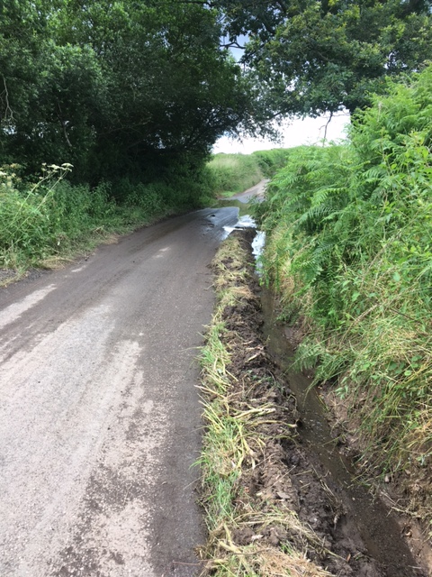
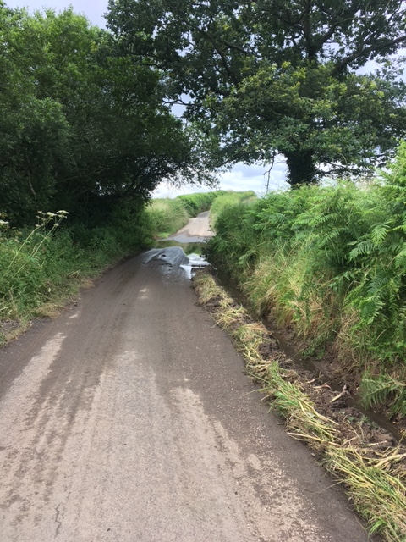
The sewage plant at East Leigh cannot cope with the volume of water passing through it. Not only does it have the sewage from the houses at East Leigh passing through it, the drainage system is such that it also has the rainwater run-off from downpipes and other surface water drains at these properties going through it. The water which overflows from the sewage plant is grey water and smells of sewage.
This has been running north down the road surface of lane towards Chilverton. In early July 2021 MDDC employees dug out the ditch on the eastside of this lane to try and channel the water off the road surface. As a result of their endeavours the earth and vegetation which was in the ditch has now been deposited on the road surface. This is a narrow lane and it is now even narrower, as can be seen in the recent photographs.
It will not be long before a wide vehicle such as an HGV or a silage trailer pushes this back into the ditch when the situation will revert to what is was.
The pictures also show the flood across the road at the dip in the lane. The 9” drainage pipe under this road has to cope with the run-off from adjoining fields as well as the road and the sewage plant. This pipe is frequently blocked, and if it were not for the efforts of an adjoining landowner who frequently clears this pipe the flooding would be much worse.
Coldridge Parish Council sees this as a problem which will require MDDC and DCC to work together to find a solution. The MDDC plant at East Leigh is overwhelmed by moderate rainfall in the area, and DCC Highways pipe under the road is inadequate. By depositing the earth and vegetation taken out of the ditch onto the road surface MDDC are not helping the problem. This detritus all needs to be removed from the area.

