SILVERTON PARISH
COUNCIL

PARISH EMERGENCY PLAN

2026

Version 1 | 2017
Version 2 | 2026
Parish Emergency Plan

Table of Contents
Introduction 3
Planning Assumptions 3
Objectives 4
Silverton Parish 4
Parish Community Response Team 5
Emergency Contact Numbers 6
Incident Action 7
Parish Key Facilities & Resources 8
Vulnerable People 10
Warning and informing 10
Annex A – Hazard Assessment 11
Appendix 15
Government Household Emergency Plan 15
About the household emergency plan 15
In an emergency 15
Meeting point 15
Important contact numbers for services you might need 15
Who else might you need to contact in an emergency? 16
Others you might want to check in on 16
List of current medication 16
Radio stations 16
Insurance details 17
Utilities 17
Emergency supplies 17
Introduction
Parish Councils in Devon are encouraged by Devon County Council (and in Mid Devon, the District Council) to write simple self-help emergency plans to enable the parish to support itself during an emergency.
There are currently no specific legal requirements for parishes to undertake emergency planning, however, S137 of the Local Government Act 1972 gives Parish Councils the power to do anything that will benefit the community (or part of it) where there is no other specific power covering the action.
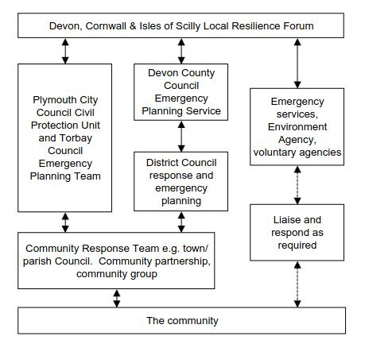
Planning Assumptions
A plan must be relevant and appropriate to the needs of the community served by the parish and should be based on an assessment of the likely and foreseeable risks faced by the community.
Most major incidents that could occur in the parish would be responded to by the emergency services or other statutory bodies and would not require significant self-help measure to be implemented.
In the event of a major incident occurring where the emergency services or other statutory bodies are unable to respond, it is likely that local residents would take action to assist those immediately affected. it will be generally confined to supporting the welfare of the people in the community. Helping to maintain normal community life, and exchanging information with statutory responding agencies. The aim of this plan is to outline how the Parish Council can contribute to the recovery from an emergency that has affected the Parish.
Objectives
- Identify the risks most likely to impact to Silverton;
- Identify, as far as it is possible, strategies to reduce and respond to an emergency, including warning the community
- Identify vulnerable people / groups / establishments in the community
- Identify community resources available to assist during the emergency
- Provide contact details for the Community Response Team
- Provide information and assistance to the emergency services when they arrive and throughout the event

Silverton Parish
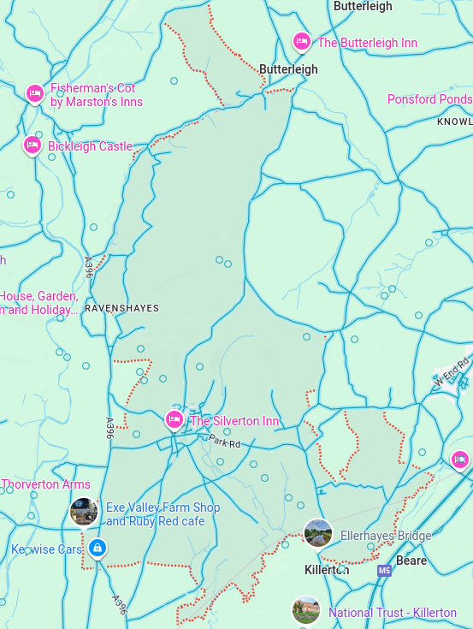

Parish Community Response Team
In the event of an emergency affecting the Parish, the Parish Council should form an Emergency Committee to work with statutory agencies to contribute to the recovery from an incident.
Emergency Committee
Name | Position | Home | Work | Mobile
Sheila Woodland | Parish Clerk | 01392 881832 | 01395 445581
 | Chair
 | Vice chair
 | Silverton Community Hall Contact
 | Silverton Inn Contact
Chris | The Lamb - Chris
Peter | St Mary’s Church -
 | Silverton Evangelical Church
Allen | Farms
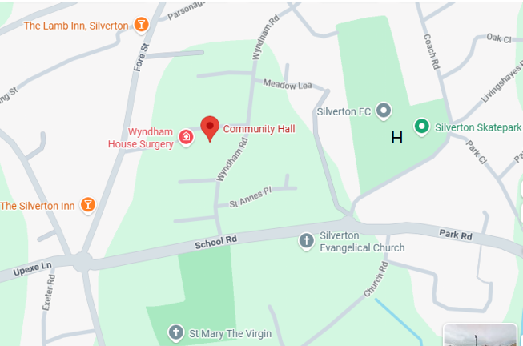

Emergency Contact Numbers
Call 999 if there is a risk to life for all emergency services, Ambulance, Police, Fire & Rescue
Service |  | Contact Number | Description
Gas Emergency |  | 0800 111 999 | National Grid Gas Emergency number for gas leaks and emergencies.
Western Power Emergency Faults |  | 0800 678 3105 | Report power outages or electrical emergencies affecting safety.
Water Supply |  | 0344 346 2020 | South West Water contact for issues with water supply and emergencies.
Railway Emergencies |  | 0800 40 50 40 | Contact for emergency incidents on rail services, including safety concerns.
Environment Agency | 03708 506 506 |  | For reporting flood incidents, checking flood warnings, and advice.
Mid-Devon Local Council | 01884 255255 |  | For local service inquiries and emergencies.
Local Authority Emergency Services | 0345 155 1015 |  | For reporting local incidents or emergency situations that affect community safe
Devon County Council | 0345 155 1015 |  | General inquiries related to services, including assistance during emergencies.
Flood-line | 0345 988 1188 |  | A 24-hour service providing flood warnings and updates.

Incident Action
A record of significant events and expenditure must be maintained throughout an emergency. These are to be kept secure by the Parish Clerk to provide documentary evidence for any subsequent enquiry and/or to support claims for financial reimbursement e.g. via insurance claims or as part of a claim made by the District Council
This is then used as hand over notes to the emergency services when they arrive.
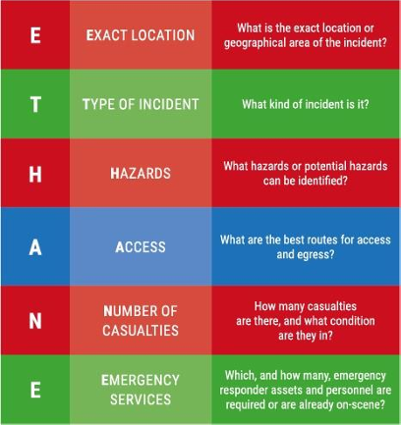

 | Instructions | Notes
1 | Example: Call 999 (unless already alerted)
2 | Ensure you are in no immediate danger
3 | If possible start keeping a log and record including times:  Any information you have and action taken with regards to ETHANE listed above:  Who you spoke to and what you said:  Any other information received:  (After 999 has been called control will contact the Mid-Devon/Devon District Team if needed)
4 | Contact the Parish Council Community Emergency Co-ordinators and if necessary they will contact: Those specifically at risk; Other members of Parish Council - via agreed route; Volunteers and key holders where appropriate.
5 | Make sure you take notes and record actions from any one to one interactions or meetings.

Parish Key Facilities & Resources
Helicopter Landing Site
Emergency Services may require a Helicopter Landing Site. There is a Devon Air Ambulance landing site at The Recreation ground in Silverton equipped with a night-time landing system
Resource | Key Holder/Contact | Key Holder/Contact | Key Holder/Contact
Silverton Community Hall
(Temporary Shelter)
Water, toilets, cooking facilities. Hall space for X people
Silverton Inn (Temporary Shelter)
Water, toilets, cooking facilities, rooms. Space for X people.
The Lamb (Temporary Shelter
Water, toilets, cooking facilities. Space for X people.
St. Peters Church -
Exe Valley Farm Shop?? in or out of the parish?
Water, toilets, cooking facilities, rooms Generator? Space for X people.
KeyWise Cars?
Farm X – Heavy lifting vehicles.
Farm Y – Transport?
?

First Aid
Wyndham House Surgery Fore Street, Silverton, Exeter, Devon, EX5 4HZ
NHS 111
Drs/Nurses local? Medical supplies.

Emergency Response Equipment
- There is no community emergency response equipment. ?? Or Defibrillators at Ellerhayes and Silverton main square.
- There are no other identified private assets which may be available for use in the event of an emergency.
ANY ONE can add here: Satellite phones? People with helpful skills. Tree Surgeons?
Considerations
Vulnerable People
It is important to ensure that isolated or vulnerable people are checked on to see if they need assistance during an emergency. Although many vulnerable people may be known to organisations such as the local authority, NHS and utility providers, others may not be known or may be made vulnerable during an Incident. This requires local knowledge, you may know someone from church that for example has a broken leg or your neighbour may be deaf, who may require extra help if they were to be affected by an emergency. There are a number of groups of people who, in an emergency, should be considered as potentially vulnerable and a priority for support and the deployment of resources, these include:
• The elderly who may not be very mobile
• Those with physical disabilities
• Those with learning difficulties
• Parents and others looking after very young children
• Those who are unable to see or have a severe sight impairment.
However, it is important to note that people may become vulnerable at any point and under different circumstances
Warning and informing
This is a responsibility of the emergency services and other statutory bodies, however emergencies are often unexpected and it is impossible to reach everyone directly. Encourage the community to contact the Emergency Committee, when they become aware of an incident to allow the team to be engaged and spread the word rapidly
Emergency Team members can be allocated to specific roads or areas to undertake door knocking to inform local residents and/or situation reporting to the management team from the ground. Both sets of information are likely to be of use to local authorities and the emergency services.
Situation updates (as known by the Emergency Committee) will be available to residents at the nominated community shelter(s) (whichever of the listed possibilities is the most appropriate in the situation)
In fluvial (river) flood-risk areas, residents should sign up to:
Environment Agency’s free Flood line flood alert service.
www.gov.uk/ and sign-up-for-flood-warnings or call 0345 988 1188 for more information.
https://www.gov.uk/government/organisations/environment-agency

During wide-spread events, further information may also be found through local media such as:
Station Name | Frequency | Type
Radio Exe | 107.3 MHz | Local Community Radio
BBC Radio Devon | 103.9 MHz | Regional BBC Station
Heart Devon | 97.0 MHz | Commercial Radio
Tiverton & Mid Devon Community Radio | 107.9 MHz | Local Community Radio

Met Office: http://www.metoffice.gov.uk/public/weather/

Annex A – Hazard Assessment
Actions in different scenarios by whom. E.g. in RED
Hazard | Likelihood | Severity | Effects & Actions
ENVIRONMENTAL
Snow | Annual light falls  Occasional heavy falls | Usually minor  Occasionally heavy and prolonged | Disruption to amenities and transport network.  Allen & farmers help to clear roads & move snow.
Flooding  Fluvial and surface water | River Exe & Culm flood plain frequently floods during periods of prolonged rainfall. | Majority of parish not in low-lying areas | Householders should take precautions to reduce impact of incident, and Home Emergency Plan (See Appendix). In the event of an incident take direction from Environment Agency and Devon CC. Households who leave their homes may need shelter.  Go to the Lamb/Silverton Inn/Community Hall/Church  Chris and who?
Flooding  Fluvial and surface water | Minor watercourses frequently flood during periods of prolonged rainfall | Relatively small number of properties affected | Properties and roads adjacent to watercourses will be affected
Flooding  Fluvial and surface water | Occasional flash flooding from stream running through High St and Fore St | Stream quickly subsides | Relatively small number of properties affected on ground floor
Flooding  Fluvial and surface water | Surface water/run-off from fields frequent during periods of prolonged | Minor impact on the roads | Properties and roads adjacent to the watercourses will be affected.  Vehicles may be required that can operate in flood water. Transporting people and other machinery.  Allen – other farmers?
Wind | More frequent in winter months | Occasionally severe  Trees blocking roads and bringing down power lines. | Risk of death or injury. Potential for widespread damage to property and disruption to amenities, particularly power and communications. If wide spread damage in Devon Emergency Services stretched therefore response times increased. Local help may be required.  Heavy lifting gear/chain saws for removing trees to clear roads.
Drought | Infrequent | Major disruption if service reduced or standpipes introduced | Restrictions on usage. Use of standpipes. Greater consequences for certain groups, e.g. elderly people, people on dialysis
Thunderstorms | Periodic, especially in summer | Can be severe | Disruption to amenities e.g. power and communications if lightening strikes.
TECHNICAL
Industrial Activities  Water treatment works | Flooded or no water | Could be severe pollution. | Spillage into near-by water courses. Unpleasant smell.
Natural gas pipelines  Explosion and fire | Possible | Severe in immediate area of incident | Major impact to life/property and environment
TRANSPORT
Road  Silverton links  Exeter/Tiverton road with Exeter/Cullompton road | Possible | Major impact to life/property and environment if heavy vehicle and/or hazardous substances involved | Danger to life/property and environment  Disruption to road traffic
Railway  Exeter to Paddington line | Possible | Major impact on premises and environment immediately adjacent to line  Lesser impact further away from line | Major disruption to rail network  Possible impact on adjacent road network.  If the crash site is in the fields away from the road. May need large trailers to transport emergency staff to the crash site & to evacuate the injured people to ambulances
Air  Flights from Exeter Airport  International airspace  Low flying military aircraft | Possible air accident. Some commercial flight paths occasionally go over the parish. Many military planes fly over weekly. | Major impact on premises and environment. | May need large trailers to transport emergency staff to the crash site & to evacuate the injured people to ambulances.  May need temporary shelter.  Go to the Lamb/Silverton Inn/Community Hall/Church  Chris and who?
MISCELLANEOUS
Thatched properties  Fire | Possible particularly during winter months | Impact on property concerned and adjacent premises | Spread of fire  Possible need for temporary accommodation and re-housing.  Go to the Lamb/Silverton Inn/Community Hall/Church  Chris and who?
Appendix

Government Household Emergency Plan

About the household emergency plan
Writing down some important information now will help you and any others you live with be ready for emergencies. Having a plan written down could help you in situations where you have no electricity, phone, or internet connection.
Download this plan and fill it in. Discuss it with those you live with. Print it out - or write it out - and keep it somewhere safe and easy to find in a power cut.

In an emergency
If the emergency is outside the home then:
- Go in - depending on the emergency you might need to close all windows and doors
- Stay in
- Tune in - monitor national and local news and follow official advice for what to do next - check local radio stations and local TV broadcasts and other trusted sources, such as your local emergency services social media accounts
If the emergency is inside the home then:
  - Get out
  - Stay out
  - Ring 999

Meeting point
In certain situations, you may need to leave your home for your own safety. Decide where you will meet others – this could be a community hub if you have one nearby. Always follow advice from emergency services about when it is safe to return home.
Agreed meeting point

Important contact numbers for services you might need
Emergency services | 999
NHS non-emergency number | 111
Police non-urgent | 101
To report a power cut | 105 in England, Scotland and Wales 03457 643643 in Northern Ireland
GP

Who else might you need to contact in an emergency?
For example, family - those within your household as well as other family members, schools or childcare, your employers, carers or clinical teams
Name | Mobile number(s) | Landline number

Others you might want to check in on
If you are in the position where you are able to offer help to your community (and it is safe to do so), you could start by checking on others such as your neighbours. Make a record of their details here:
Name | Address | Landline | Mobile

List of current medication
Medication name | Dose | How often | Who takes it

Radio stations
Here you should make a note of the frequencies of any radio stations you use to get local or national news.
Radio Exe | 107.3 MHz
BBC Radio Devon | 103.9 MHz
Heart Devon | 97.0 MHz
Tiverton & Mid Devon Community Radio | 107.9 MHz

Insurance details
Insurance company names, phone numbers and policy numbers

Utilities
If you have time and it is safe to do so, you might need to turn off the mains water, gas or electric to your home during an emergency. Familiarise yourself with where these are located.
WARNING: You can turn the water and electricity back on yourself but NOT THE GAS. This must be done by a qualified engineer.
Utility shut off | Location
Water stop cock
Gas isolation valve
Electricity isolation switch

Emergency supplies
Consider what supplies you and your household might need during an emergency lasting a few days. You could consider keeping the following items at home:
- Battery or wind-up torch
- Portable power bank for charging your mobile phone
- Battery or wind-up radio to get updates during a power cut
- Spare batteries for torch or radio
- First aid kit
- Wet wipes and hand sanitiser
- Bottled water
- Non-perishable food that does not require cooking (e.g. tinned meat, fruit or vegetables) and tin opener
- Baby supplies (e.g. nappies and formula)

